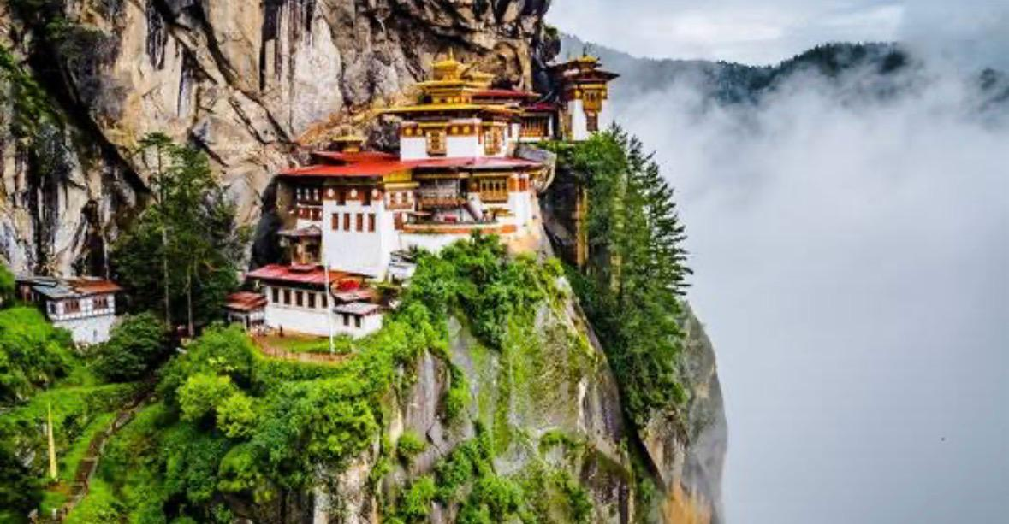
TRAVEL ALLY HOLIDAYS PVT LTD
Dear Sir,
Greetings from Travel Ally Holidays Pvt Ltd .
Thank you for choosing Travel Ally Holidays Pvt Ltd for your preferred service. We are pleased to provide you the details related to your booking enquery, as follows.
Package Name-6 Nights 7 Days BhutanTour
Day 1: Pick up From Bagdogra Airport / NJP Station - Transfer to Phuentsholing - Immigration Formalities - Night Stay (Distance: 155 km / Driving Time: 4 hr / Altitude of Phuentsholing: 293m)

On the arrival of the guest at Bagdogra Airport / NJP Station, One of our representatives will be there to assist you. After meeting & greeting, will transfer towards Phuentsholing. At Phuentsholing, clear the immigration formalities at the Pedestrian Terminal. Once you get the inner–line permit. Check into your pre-booked hotel. After refreshment, take a rest. Evening leisure in the main market at Phuentsholing by walking. Overnight stay at Phuentsholing. (Altitude 293m)

Day 02: Immigration Formalities - Transfer to Thimphu - Night Stay (Distance: 163km / Driving Time: 6 hr / Altitude of Thimphu: 2334m)

After morning breakfast, clear the immigration formalities in the immigration office. Once you get the inner-line permit drive towards Thimphu, which takes almost 6 hours to reach. On the way, you can visit Kharbandi Gumba. The journey will be beautiful surrounded by mountains. On the way to Thimphu see the waterfall. Once you reach Thimphu. Check into your pre-booked hotel & after refreshing and take a rest.
• Bhutan gate
• Kharbandi Gumba
• Waterfall
Evening time can be spent strolling through the government-run Handicrafts Emporium and local crafts bazaar, to browse through examples of Bhutan's fine traditional arts. Here you can buy hand-woven textiles, thangka paintings, masks, ceramics, slate and wood carvings, jewellery, and interesting items made from local materials.
Overnight at the hotel in Thimphu. (Altitude 2,320m)

Day 03: Transfer Thimphu to Punakha Sightseeing – back to Thimphu Night Stay (Distance: 148km / Driving Time: 6 hr / Altitude of Punakha: 1300m)

After morning Breakfast, transfer to Punakha from Thimphu which takes approx 3 hr one way. On the way cover below sightseeing places. After sightseeing drive back to Thimphu.

Dochula Pass:
The Dochula Pass is a mountain pass in the snow-covered Himalayas within Bhutan on the road from Thimpu to Punakha where 108 memorial chortens or stupas known as "Druk Wangyal Chortens" have been built by Ashi Dorji Wangmo Wangchuk, the eldest Queen Mother. Apart from the chortens, there is a monastery called the Druk Wangyal Lhakhang (temple), built in honour of the fourth Druk Gyalpo (head of the state of Bhutan), Jigme Singye Wangchuck; the open grounds in its front yard is a venue for the annual Dochula Druk Wangyel Festival. The pass with 108 memorial chortens is adjacent to the country's first Royal Botanical Park.
Punakha Dzong:
It was built in 1637 by Shabdrung Ngawang Namgyal, at the junction of the Phochu and Mochu rivers. This majestic dzong served as both the religious and administrative centre of Bhutan in the past. It measures some 600 by 240 feet and has a six-story, gold-domed tower. Inside are courtyards and religious statuary that hint at the depth of history and spiritual tradition embodied here.
• Punakha Suspension Bridge

Overnight at the hotel in Thimphu. (Altitude 2,320m)

Day 04: Full Day Thimphu Sightseeing – Transfer to Paro - Night Stay (Distance: 50km / Driving Time: 1.5 hr / Altitude of Paro: 2200m)

Thimphu is the capital of Bhutan. After morning breakfast, you can start your local sightseeing at Thimphu by covering the places below.
Later drive to Paro.
• National Memorial Chorten
• Tashidzong (only view)
• Buddha Point
• Simply Bhutan
• Changangkha Lhakhang
• Motithang Takin Preserve
• Handicraft Market
Overnight at the hotel in Paro. (Altitude 2,200m)

Day 05: Tiger’s Nest Monastery Hike :

After an early breakfast, Taktsang Monastery it may take 6 hr (to n fro). Suggest taking a hot Stone bath and spa after trekking for body relaxation.
Evening free for an exploratory walk around Main Street and the market area by walking. Tiger’s Nest Monastery (Taktsang Lhakhang) is Bhutan’s most iconic landmark and religious site. The name Taktsang translates to “The Tiger’s Nest”. This temple is one of the most holy sites in the kingdom. It is believed that Padmasambhava (Guru Rinpoche) flew to this location from Tibet on the back of a tigress from Khenpajong. This place was consecrated to tame the Tiger demon and was first built in 1692 at a cave where Guru Rimpoche meditated in a cave. To arrive at the temple you must trek for around 2-3 hours through beautiful, shady pine forests that are colourfully festooned with moss and prayer flags.
• Hot Stone Bath & Spa (at extra cost)
• Paro Local Market by walking

Evening free for leisure.
Overnight stay at a hotel at Paro. ( Altitude 2200 mts)

Day 06: Excursion to Chele-La-Pass and later drive to Phuentsholing - Night Stay (Distance: 142km / Driving Time: 5hr / Altitude of Phuentsholing: 293 mts.)

After breakfast, Excursion to Chele-La-Pass:

The 35km drive to Cheli la makes an interesting road excursion and is an excellent jumping-off point for day walks. Chele la separates Haa and Paro valley and at 3988m, it is one of the highest motorable passes in Bhutan. The drive till here from either Paro or Haa is through dense spruce and larch forests according to the seasons. On a clear day, there are spectacular views of Mt. Jumolhari, Jichu Drake and adjoining peaks to the North West, as well as the view of Haa and Paro Valley. Later drive to Phuentsholing .After finishing your sightseeing drive to Phuentsholing - check into your pre-booked hotel at Phuentsholing - evening free for leisure in the town to explore by walking.
Overnight stay at hotel at Phuntsholing.

Day 07: Drop Phuentsholing to Bagdogra Airport ( 4hrs drive) (Distance: 155 km / Driving Time: 4 hr)

After breakfast check out from the hotel and drop at Bagdogra Airport for your onward journey. As you go home let the everlasting memory of the radiant Himalayas and this beautiful serene kingdom linger in your mind and prompt you now and again to revisit this place.

Inclusions:
• 6 Nights accommodation in 3-star hotels on double sharing.
• For Solo Travelers rooms will be double or triple sharing basis as per the same gender.
• All the properties are rated under the Tourism Council of Bhutan (TCB)
• 2 Nights Phuentsholing, 2 Nights Thimphu & 2 Nights Paro Stay.
• Meal Plan - 6 Breakfast & Dinner at accommodated hotels.
• 1 Complimentary Tourist SIM card with 100 Minutes of Talk Time in each group
• Pickup and drop from Bagdogra Airport (IXB) on a sharing basis.
• All transfers and sightseeing as per the Itinerary on a sharing basis.
• Tourist Permits to Travel to Thimphu, Punakha & and Paro.
• Driver allowances, toll tax, parking charges, and state taxes.
• Bhutanese certified tour Guide to Coordinate throughout the trip.
• Rs. 1200 per day Sustainable Development Fee (SDF) or Visa Cost Included.
• Royal Bhutan Travel Insurance (Mandatory)
• 1 water bottle per day per person complimentary at Bhutan part
• 24hrs customer service
• Rates are valid for Indian National only

Exclusions:
• Any Airfare or Train Fare ( Airfare Deals Available ).
• Lunch, any extra meal/beverages not mentioned in the package.
• Additional sightseeing or extra usage of vehicles, other than those mentioned in the itinerary or Optional Tours.
• Any activities, permits, monuments entrance fees or transfers other than those mentioned in the Itinerary.

• Any expenses caused by reasons beyond our control such as rescheduling or cancellations e.g. flight cancellations, any accidents, weather conditions, medical evacuations, riots, strikes etc. Such expenses will have to be paid directly.
• Any other expenses specifically not mentioned above
• 5% GST & 5% TCS as per government norm

Pickup & Drop Time:
• Pickup Time: 2:00 PM to 2:30 PM from Bagdogra Airport on Day 1.
• Drop Time: We will drop you off before 2:00 PM at Bagdogra Airport on Day 7.
• Kindly consult with us before booking your flights

Per group in India, the part for pick up and drop cab will be Innova or a similar traveller bus. At Bhutan, the part cab will be a Toyota Hiace bus, Toyota coaster bus or SUV.
DEPENDING ON THE GROUP SIZE Vehicle may change subject to final group size.
The vehicle will be available as per itinerary and point to point-to-point basis.The driver will drop you at the hotel after completing the sightseeing. Additional sightseeing or extra usage of vehicles, other than mentioned in the itinerary or Optional Tours will be charged separately by the driver.
RULES FOR VISIT TO BHUTAN
• PASSPORT OR VOTER ID CARD 18 YEARS AND ABOVE
• FOR CHILDREN BELOW 18 YEARS PASSPORT OR BIRTH CERTIFICATE (ENGLISH WRITTEN CERTIFICATE)
• SDF CHARGES COMPULSORY 1200/- PP PER NIGHT FOR ADULTS (13 YEARS AND ABOVE) AND 600/- PER CHILD PER NIGHT BETWEEN (6-12 YEARS) AND CHILD BETWEEN 1-5 NO SDF CHARGE REQUIRED.
• PASSPORT SIZE PHOTOGRAPH REQUIRED
• DOCUMENTS PHOTOCOPY REQUIRED
• TRAVEL INSURANCE REQUIRED

- NB:Feel free to contact us for any kind of assistance and assuring you best of services of all time.Tour customization is possible as per your requirement ratherthan sticking on the fixed plans. We can easily customize the itinerary based on your budget, interests and schedule. Please contact us to discuss your individual requirements.

TRAVEL ALLY HOLIDAYS PVT LTD
- 2nd Foor ,Friends Arcade,
- K.S.N. MenonRoad,Ernakaulam.682016
- Phone:9946973797 ,8590300348
- Email-Id :travelally416@gmail.com.
www.travelallyholidays.com
_______________________________________________________________________________

