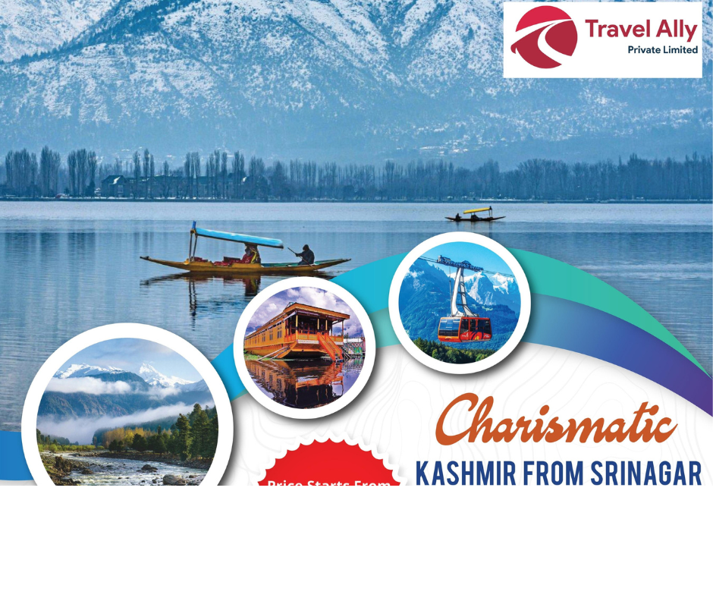
TRAVEL ALLY HOLIDAYS
Dear Sir,
Greetings from Travel Ally Holidays Pvt Ltd .Thank you for choosing Travel Ally Holidays Pvt Ltd for your preferred service. We are pleased to provide you the details related to your booking enquiry as follows.

Package name: 4N 5D Kashmir Package
Destinations : Srinagar - Sonamarg - Gulmarg - Pahalgam
No. of Pax:
DAY WISE ITINERARY

DAY 01. ARRIVAL AT SRINAGAR AIRPORT & LOCAL SIGHTSEEING

Arrival at Srinagar Airport, assistance on arrival and proceed towards hotel check-in in to your reserved hotel. After that leave for Sightseeing tour of Mughal Garden Visiting, Cheshmashahi (The Royal Spring), Nishat (The Garden of pleasure), Shalimar (The Abode of Love) after that you can go for Shikara ride in world famous dal lake which is complimentary by our company for 1 hour you can capture the beautiful view of dal lake and then return back to hotel & Overnight at the Hotel in Srinagar.
DAY 02. SRINAGAR TO PAHALGAM DAY TRIP (96KM ONE WAY)

After breakfast, leave the hotel & drive towards pahalgam. Pahalgam is also known as “Village of Shepherds" Reroute visiting the world-famous Saffron growing fields, Awantipura ruins (9th century) & Martand Temple (sun temple). Pahalgam is famous for the Indian film industry, some trekking routes & also a base camp for Amarnath Pilgrimage. On reaching Pahalgam you can explore some local markets and can admire fresh Mountains and river. You can visit the “Baisaran valley” (Mini Switzerland of India by hiring a pony on direct payment basis) or one can go to the ABC valleys Aru Valley, Betab valley & Chandanwari (by hiring a local union cab on direct payment basis). And return back to Srinagar, and overnight stay in hotel at Srinagar.

DAY 03. SRINAGAR TO GULMARG DAY TRIP (58KM ONE WAY)

After breakfast leave the hotel in Srinagar & drive towards Gulmarg (8700 ft a.s.l) “Meadow of Flowers". Gulmarg has a famous Golf Course during summer (which is one of the highest 18-hole golf courses in the world) & ski Resort during winter. This day you can see some famous things in the way to Gulmarg and you cango to gondola ride “The largest cable car ride” in Asia which is famous all over India. There are two phases in this cable car ride: 1st & 2nd phase. 1st phase is 7 minutes ride from gondola to kongdoori (8,530 ft above the sea level) & 2nd phase is 15 minutes ride from kongdoori to affarwat peak (12,293 ft above the sea level) you can enjoy the ride and return back to Srinagar for overnight stay.

DAY 04. SRINAGAR TO SONAMARG DAY TRIP (85KM ONE WAY)

After breakfast, leave for a full day Excursion tour of Sonamarg (9000 fts a.s.l). Sonamarg "The Golden Meadow” is the beginning of the enchanted journey into a natural wonderland. Surrounded by mountains up to 5300 high, the valley is divided by a spur of the “Thajwas Range”. You can go to Thaijwas Glacier (by hiring a pony on direct payment basis) where the last scene of Bajrangi bhaijan movie was filmed or you can go to Zero point (by hiring a local union cab on direct payment basis). Later drive back to Srinagar and overnight stay in Houseboat at dal lake Srinagar.

DAY 05. DEPARTURE TO SRINAGAR AIRPORT

After having breakfast, leave for Srinagar Airport to catch your flight early.

Inclusions: | Exclusions:
➢Pickup and drop at Srinagar airport. | ➢Personal Expenses such as tips, Shopping, Lunch, laundry, & table Drinks etc.
➢Comfortable accommodation for 4 Nights.
➢Transportation throughout the trip. | ➢ Activities expenses
➢Breakfast and Dinner included. | Garden entrance fee @100 - 200 Per Person
➢Complimentary Shikara Ride at Dal Lake. | ➢ Pony Ride in Gulmarg/Pahalgam
➢Sightseeing tour as per the itinerary. | ➢ Cable Car rides in Gulmarg both phases.
 | ➢Union cab for trip to Aru , Betab valley and chandanwari.
➢All tol taxes, driver allowances, parking charges. | ➢ Guide services in Gulmarg
➢Vehicle provided is not on sharing basis. | ➢ Local taxi for Zero Point Sightseeing in Sonamarg.
➢Child up to 05 years will be complimentary. | ➢Expenses caused by factors beyond our control like rail and flight delays, roadblocks, vehicle mal- functions, political disturbances, taxes etc.
- NB:Feel free to contact us for any kind of assistance and assuring you best of services of all time.Tour customization is possible as per your requirement ratherthan sticking on the fixed plans. We can easily customize the itinerary based on your budget, interests and schedule. Please contact us to discuss your individual requirements.

TRAVEL ALLY HOLIDAYS PVT LTD
2nd Foor ,Friends Arcade,
K.S.N. MenonRoad,Ernakaulam.682016
Phone:8590300348,8075 305 995
Email-Id :travelally416@gmail.com.
__________________________________________________________

