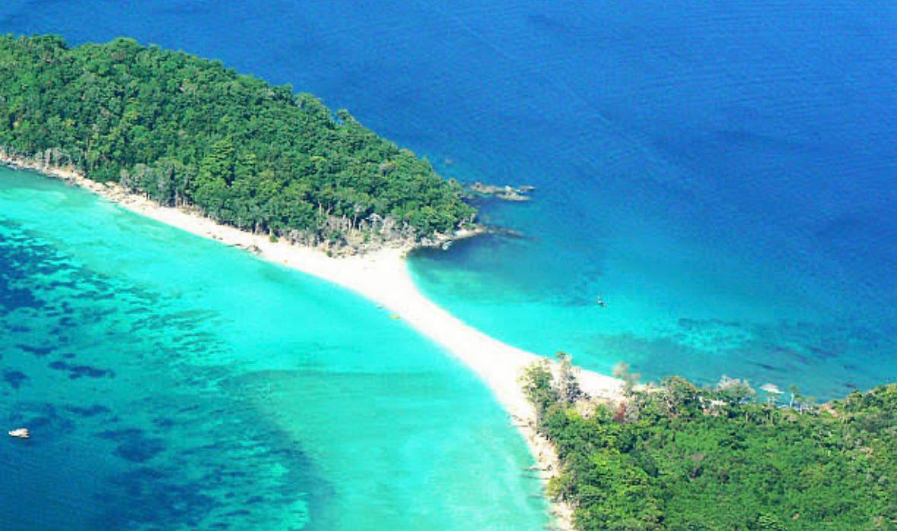

PACKAGE NAME

Distinctive Andaman
Duration: 4 Nights Port Blair ( 2 Night Port Blair 2 Night Havelock)

Day 1 | Arrival at Port Blair Cellular Jail, Corbyn's Cove Beach and Sound & Light Show Port Blair
Day 2 | Onward journey to Havelock Island - Radhanagar Beach Havelock
Day 3 | Havelock Island- Elephant beach and Kalapather beach.
Day 4 | Havelock Island- Kalapather Beach And Return To Port Blair
Day 5 | Escort to Airport

Package Includes
- Accommodation on twin sharing in the hotels .
- Daily breakfast will be provided by the hotel during stay.
- Private (Non Sharing) AC vehicle (Xylo/Ertiga/Scorpio/Desire) at all islands for pickup and drop as per the above itinerary.
- Luxury AC Cruise (Nautika/Makruzz) tickets for Havelock/Neil Island and return journey. In case of budget package
- Green Ocean Cruise Tickets (Economy Class) will be provided.
- Complimentary snorkeling at Elephanta Beach by Elephanta Beach Boat Association
- Complimentary shopping at Sagarika Emporium
- Assistance of Tour Coordinator during the tour.
- Airport pickup and drop.
- Entry Tickets, Permit Fees, Boat/ Ferry Tickets to visit all the places of sightseeing mentioned in the itinerary
- No hidden charges
Package Excludes
- GST
- All kinds of personal expenses such as tips, laundry, telephone bills, beverages, etc.
- It also does not include those meals which are not mentioned in the inclusions section.
- Domestic or International Airfare.
- Guide, Glass bottom boat rides, speed boat ride, snorkeling charges, etc.
- Guide at Cellular Jail and Ross Island.
- Camera fee (still or movie)
- Any additional charges arising due to natural calamities, political disturbances, vip movement, etc.
- Everything that is not mentioned in the inclusions.
- Detailed Itinerary

Day 1: Arrival at Port Blair Cellular Jail, Corbyn's Cove Beach and Sound & Light Show
On arrival at Port Blair, meet your guide then Check-in to your hotel. After having Lunch, visit one of the most enchanting beaches in the region, the Corbyn's Cove Beach, Your First visit as well. Later On, Move ahead to visit the Cellular Jail, witnesses the historical remnants of British reign in India. TakethePleasure of Light and Sound Show that displays the dark days the Indian freedom fighters have gone through. After the show ends, you will be transferred back to your Hotel.
Day 2: Onward journey to Havelock Island - Radhanagar Beach
The very pleasant day , proceed to Jetty to take the Luxurious Cruise to Havelock Island. On arrival at Havelock Island, our staff will greet you and will escort you to the hotel/resort for check-in. Later, proceed to Radhanagar Beach, Where White sand & rainforest trees lend a tropical vibe. Later, return back to the resort/hotel for an overnight stay
Day 3: Havelock Island- Elephant beach and Kalapather beach
Early morning proceed to Havelock jetty to take a sharing fibre speed boat to Elephant. The energetic beach offers tranquil blue shallow water to professional as well as beginner snorkelers. Elephanta beach is Ultimate for snorkelling and other water sports activities like swimming, speed boat rides. Later in the evening visit Kalapather Beach. Closing the trip and return back to the hotel/resort at Havelock Island for an overnight stay.
Day 4: Havelock Island- Kalapather Beach and return to Port Blair
Morning after check-out and breakfast, proceed to Kalpather beach, this is one of the most beautiful beach at Havelock. Later, return back to the jetty from where you will take Cruise towards Port Blair. At Port Blair our staff will receive you and will let you check-in to the Hotel for an overnight stay.
Day 6: Escort to Airport
NB:Feel free to contact us for any kind of assistance and assuring you best of services of all time.Tour customization is possible as per your requirement ratherthan sticking on the fixed plans. We can easily customize the itinerary based on your budget, interests and schedule. Please contact us to discuss your individual requirements.
Travel Ally Holidays Pvt.Ltd,
Friends Arcade,
K.S.N. MenonRoad,Ernakaulam.682016
Phone:8075305995 ,8590300348.
Email-Id :travelally416@gmail.com
__________________________________________________________________

