Golden Triangle with Mathura&Vrindavan Tour

Golden triangle is a tourist circuit which includes: Delhi, Agra (including the Taj Mahal), and Jaipur. The Golden Triangle is now a well-travelled route and is so called because of the triangular shape formed by the locations of New Delhi, Agra and Jaipur on a map. These three cities are extremely popular as tourist destinations among the foreign tourists visiting India as well as among the natives. The circuit is about 1000 km by road. The New Yamuna Express Highway between Delhi and Agra is a landmark in tourist movement.

Duration:5 Nights / 6 Days

Places Covered : Delhi – Mathura – Vrindavan - Agra – Fatehpur Sikhri - Jaipur

Program

Day 01 : Arrive Delhi
Arrive Delhi.On arrival, proceed for sightseeing of the city visiting Red Fort - the old Mughal Administration centre for 200 years built by Shah Jahan, Raj Ghat, the cremation place of Mahatma Gandhi, India Gate and war memorial. In the evening visit Akshardham Temple with the sound & light show. Drive to the hotel. Night stay at the hotel.

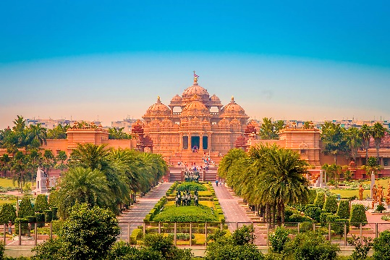
Akshardam Temple

Day 02 : Delhi Sightseeing
Breakfast at the hotel. Today, full day tour of Delhi - drive past President’s house and Parliament House, visit Indira Gandhi Musuem, National Museum, Lotus Temple, Qutub Minar and Humayun’s Tomb. Evening free for shopping at Sarojini Nagar market. Night at the hotel.

Day 03 : Delhi –Mathura – Vrindavan - Agra
In the morning, proceed to Mathura (195 kms / 4hrs). On the way visit Mathura Sri Krishna Temple and Vrindavan. Further proceed to Agra (45 kms / 1 hr) and visit Taj Mahal, the eternal monument built by Shah Jahan in memory of his wife Mumtaz. Night at the hotel.

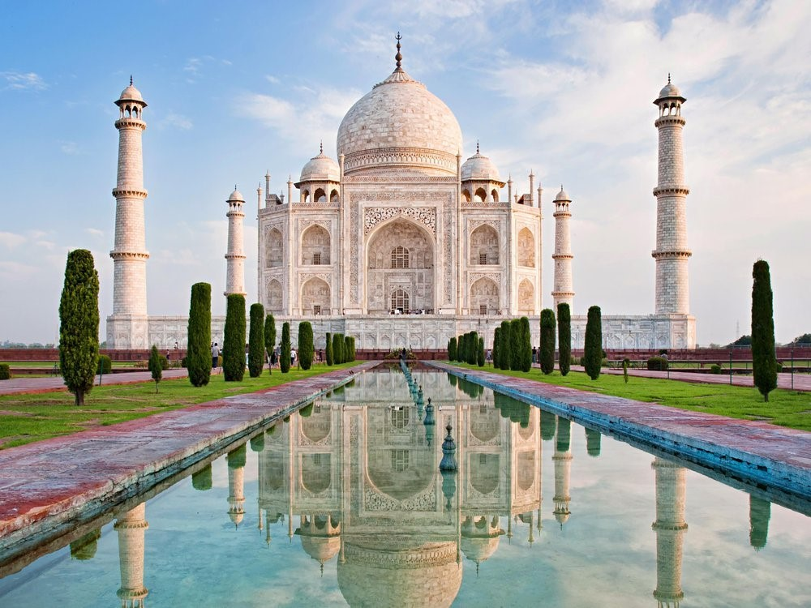
Taj Mahal
Day 04 : Agra – Fatehpur Sikhri – Jaipur
Breakfast at the hotel. Morning visit Agra Fort, the huge red fort structure of length nearing one kilometer. Later, proceed to Jaipur (255 kms / 5 hrs) enroute visiting Fatehpur Sikhri, the old Mughal capital still preserved in good condition. You may also visit the nearby Masjid. On arrival at Jaipur, visit Birla Temple. Watch Albert Museum from outside.Check into hotel.

Day 05 : Jaipur
Breakfast at the hotel. Morning proceed to the outskirts of the city and visit the majestic Amer Fort which is situated on top of the hill. It is one of the biggest forts of Jaipur and visited millions of people yearly. Stop at Jal Mahal for phots. Afternoon, drive past Hawa Mahal to City Palace. Part of the Palace is still occupied with the Present Rajas and their family members. Visit Jantar Mantar.Evening move around the colorful local markets. Night at the hotel.

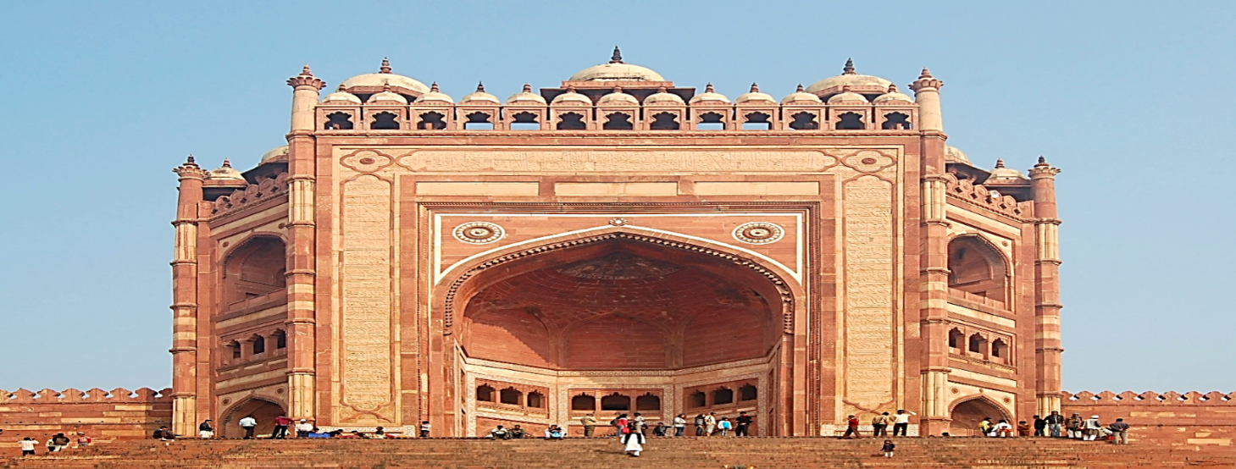
Fatehpur Sikhri

Day 06 : Jaipur – Departure
In time, transfer to Jaipur airport / Delhi airport (300 Kms – 4hrs.) for onward destination.

Included services
- Accommodation:2 rooms @ 5 nights as per itinerary (Hotel Check-in / Check-out time 13:00 / 11:00 Hours).
- Meals: Buffet breakfast and dinner at the hotel.
- Transport: All transport services using A/c Vehicle

- Excluded services
- Any air / train fare
- Any Guide / Escort services
- Any expenses of personal nature such as telephone, laundry, alcohol etc.
- Any elephant ride charges in Jaipur
- Any meals other than specified
- Any Monument Entrances fee
- Tips & portage at the Hotels/Restaurants/Driver

- NB:Feel free to contact us for any kind of assistance and assuring you best of services of all time.Tour customization is possible as per your requirement ratherthan sticking on the fixed plans. We can easily customize the itinerary based on your budget, interests and schedule. Please contact us to discuss your individual requirements.

TRAVEL ALLY HOLIDAYS PVT LTD
2nd Foor ,Friends Arcade,
K.S.N. MenonRoad,Ernakaulam.682016
Phone:8590300348,8075305995 .
Email-Id :travelally416@gmail.com.
____________________________________________

