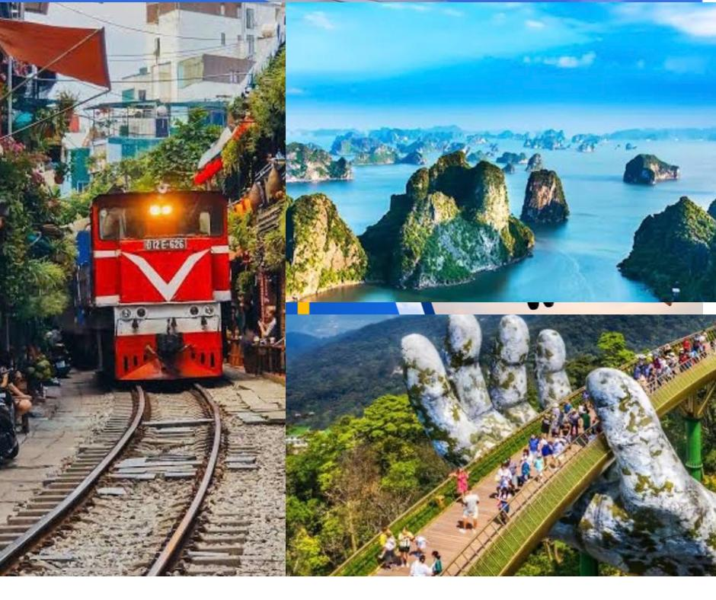
TRAVEL ALLY HOLIDAYS

Dear Sir/Madam,
Greetings from Travel Ally Holidays Pvt Ltd .
Thank you for choosing Travel Ally Holidays Pvt Ltd for your preferred service. We are pleased to provide you the details related to Vietnam Package.
Package Name-4 Nights 5Days Vietnam Package
No.of Pax -
ITINERARY

Day 01: Arrival in Hanoi + Half Day City Tour Pvt
Our driver will pick you from the airport and transfer to the hotel. Rest For the Day until the tour starts.
Pick-up time: Around 13:00–13:30 from your hotel (exact time may vary).

1:00 PM – 2:00 PM | Trấn Quốc Pagoda
Start your afternoon at Trấn Quốc Pagoda, the oldest pagoda in Hanoi, located on the peaceful West Lake. Admire its ancient architecture, serene atmosphere, and beautiful lakeside setting.

2:15 PM – 3:15 PM | Hoàn Kiếm Lake
Next, head to Hoàn Kiếm Lake, the heart of Hanoi. Stroll around the lakeside, enjoy the tranquil scenery, and learn the legend of the Hoàn Kiếm sword. Don’t miss Ngọc Sơn Temple on the small island.
3:30 PM – 4:30 PM | Train Street
Experience the unique Hanoi Train Street, where trains pass just a few feet from local houses and cafés. Enjoy a coffee while witnessing this one-of-a-kind cultural sight.

4:45 PM – 5:45 PM | St. Joseph’s Cathedral (Catholic Church)
Conclude the tour at St. Joseph’s Cathedral, a stunning neo-gothic church built in the late 19th century. Learn about its history and enjoy the lively Old Quarter atmosphere surrounding it.

✅ Total Duration: 1:00 PM – 5:45 PM ✅ Inclusions: Licensed local guide, sightseeing, cultural insights.
After the City tour, Car drops you at the Hotel.
Day 02: Halong Bay Day Cruise SIC
08h: Picking up from hotel in Oldquarter or Hanoi Opera House depart for Tuan Chau harbor by modernist highway in Vietnam, stop over for a rest on the way 11h30-12h0: Arriving Tuan Chau Harbor, welcome on-board and safety briefing Boat cruising passages, uninhabited islets and outcrops have been given imaginative names by the locals, due to their perceived shapes, including Cock Fighting and Thumb, while enjoying Vietnamese mouth-watering lunch on boat. 13h30: Arrive area doing kayaking or bamboo boat explore the bay by your own paddle .14h00: Visit Amazing cave , Sung Sot (Surprise) Cave: Explore The Biggest Cave in Halong Bay A place so amazing that the French deemed it “Grotte des Surprises” or (Surprise Grotto), Sung Sot Cave is one of the biggest, most beautiful caves in Halong Bay and a highlight on most Halong Bay itineraries. 15h00:Keep moving to Titop Island, it's time for you to relax on the beach or climb up the TOP for Panoramic View of Halong Bay. 16h30: You will be back to the cruise for Afternoon Vietnamese tea cake during cruising back toward Tuan Chau harbor .18h00:Boat arrive harbour, get on the bus back to Hanoi 20h30-21h-00: Drop off at your hotel/stay, trip ends.

Day 03: Fly to Danang + Hoi An Tour+Lantern Boat Ride
Our driver will take you to Hanoi Airport for your flight to Danang. Upon Arrival, the driver will pick you up from the airport and drop you off at the hotel, rest till the tour starts.
Pick up from Hotel
Meet Our licensed guide and transfer to mCoconut village near Hoi An.
Travel to Hoi An Ancient Town
Arrive in Hoi An,a UNESCO World heritage site.Stroll through Lantern-lit streets,visitthe Japanese Covered bridge,ancient merchant houses,and burstling markets.Free time to shop,capture stunning photos,or taste local specialitieslike Cao Lau noodles and Banh mi.
Lantern boat ride on the Thu Bon River(Inclusive Ticket).
After Tour/Return to Hotel
Board the vehicle for a comfortable transfer back to your Hotel.

Day 04: Bana Hills + Golden Hand Bridge Tour Pvt
7:00 AM – Breakfast at Hotel Enjoy breakfast at your hotel before starting the tour.
8:00 AM – Transfer to Bà Nà Hills Station Drive to Bà Nà Hills Cable Car Station. Take a ride on one of the world’s longest cable cars, offering stunning bird’s-eye views of mountains, forests, and clouds.
9:00 AM – Explore French Villas & Mountain Peak Visit the old French villas, walk across the suspension bridge, and continue up to Núi Chúa Mountain Peak at 1,487m for panoramic views of Da Nang and its surroundings.
12:00 PM – Lunch with Local Dishes Enjoy a delicious Vietnamese lunch at a restaurant on the mountain while admiring spectacular scenery.
Afternoon
1:30 PM – Fantasy Park Spend free time at Fantasy Park, Vietnam’s only indoor amusement park located on a mountaintop. Enjoy games, rides, and fun activities for all ages.
3:00 PM – Golden Bridge (Cầu Vàng) Visit the iconic Golden Hands Bridge, a 150m-long pedestrian bridge held by two giant stone hands. This stunning landmark has become one of Vietnam’s most photographed attractions.
4:30 PM – Cable Car Downhill Take the cable car back, enjoying the last views of Bà Nà Hills from above, and the Car will drop you off at your hotel.

Day 05: Departure
Enjoy breakfast at the hotel, check out, and transfer to the airport for your onward departure. Our driver will pick you up from your hotel. You have to reach the airport 3 hours before the departure.

TOUR COST INCLUDES: | TOUR COST NOT INCLUDES:
● Halong Bay Day Cruise - Group tour  ● All entry tickets paid by us.  ● Private transfer from airport to hotel & Hotel to airport  drop and Pick up  ● Shuttle Bus for SIC Tours  ● English Speaking Guide  ● Two bottles of water per person per day | ● Domestic Flights (Actual Cost)  ● International Flights  ● Other services than mentioned  ● Laundry, telephone calls and expenditure of a personal nature  ● Tips (3 USD/pax/ day tour – Compulsory for private tour & optional for group tour)  ● Unforeseen expenses in the event of tour cancellation due to forced major situations such as natural disasters, adverse weather conditions, or strikes...  ● Water / Drink On Cruise
Notes:
● Flight fares are subject to change
● Validity of the passport should be a minimum of 6 months from the intended date of return
● Compulsory tip for the guide and driver will be added (3 USD/adult/day tour)
● Please print out the E Visa for smooth immigration process
● Please adhere to the time to make everyone comfortable or else you may miss the attractions
● Any transportation outside of the scheduled times may incur additional charges

Cancellation Policy:
1. Flights and VISA fee is non-refundable
2. Cancellation made within:
a. 7 days prior to departure date: 100% of reservation cost (after deduction of flights and VISA fee)
b. 8-14 days prior to departure date: 50% of reservation cost (after deduction of flights and VISA fee)
c. 15-29 days prior to departure date: 25% of reservation cost (after deduction of flights and VISA fee)
d. 30 or more days prior to departure date: 10% of reservation (after deduction of flights and VISA fee)
Other Terms & Conditions:
1. Any overstay expenses due to delay or change or cancellation in flight will be on the guests own & we will not be held liable for such expenses however we will provide best possible assistance. Holiday Surcharge will be additional if applicable
2. The passengers must ensure on their own that they have a valid passport and other required documents for the necessary period as per the traveling destination immigration rules.
3. The passengers should also arrange for visas before traveling with this holiday package if applicable.
4. It is beyond our responsibility if the passenger cannot travel because of a passport or visa issue at any point. The cancellation policy will be applicable as per the booking terms and conditions

 | 6 Pax | Meals | 4* Hotel
DAY-1 | Arrival in Hanoi+City Tour Half day PVT |  | Muang Thang
Day-2 | Day Cruise SIC | Breakfast,Lunch | Muang Thang
Day-3 | Fly to Danang+Hoi An+Lantern Boat ride . | Breakfast | Cosmos
Day-4 | Bana hills Full day Tour | Break fast | Cosmos
Day-5 | Departure | Breakfast
- NB:Feel free to contact us for any kind of assistance and assuring you best of services of all time.Tour customization is possible as per your requirement ratherthan sticking on the fixed plans. We can easily customize the itinerary based on your budget, interests and schedule. Please contact us to discuss your individual requirements.

For more details contact
Travel Ally Holidays Pvt.Ltd,
K.S.N. MenonRoad,Ernakaulam.682016
Phone:8075305995 ,8590300348.
Email-Id :travelally416@gmail.com
www.travelallyholidays.com

__________________________________________________________________________________

