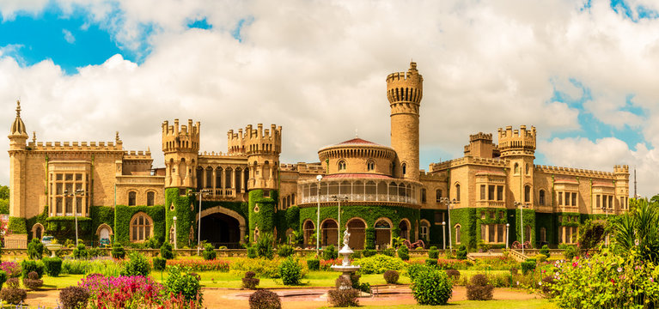

TRAVEL ALLY HOLIDAYS

Package Name :-BANGALORE - 2Nights, 3Days

Dear Guest,
Thank you for choosing Travel Ally Holidays Pvt Ltd for your preferred service. We are pleased to provide you the details related to your booking enquiry , as follows.
Details
Package Name- 2 Nights 3Days -Bangalore Package
No.of Pax-

Major Sightseeing Destinations inBangalore:-
Nandi Hills
Lalbagh Botanical Garden
Bannargatta National Park
Aiyra museum
HAL museum
Vishweshwariah Museum
Bangalore Palace
Iskon Temple
Nehru Planatorium
(Covering of the sightseeing places are entirely depends up onthe availability of time)

2 night accommodation
All transfers by private vehicle
All Toll,Parking and Driver Bata
Sightseeing as per the itinery depends up on the availability of time.
Any monument Entrance tickets
Personal Expenses
Any Meals not mentioned in the itinerary .
Cost of services which is not mentioned in the "inclusions".

- NB:Feel free to contact us for any kind of assistance and assuring you best of services of all time.Tour customization is possible as per your requirement ratherthan sticking on the fixed plans. We can easily customize the itinerary based on your budget, interests and schedule. Please contact us to discuss your individual requirements.

For more details contact
Travel Ally Holidays Pvt.Ltd,
K.S.N. MenonRoad,Ernakaulam.682016
Phone:8075305995 ,8590300348.
Email-Id :travelally416@gmail.com
www.travelallyholidays.com

_____________________________________________________________________

